Mayland Parish Council Notice to all dog owners/walkers using Lawling Park

Mayland Parish Council (MPC) will be putting up signs on Lawling Park Football Field and Bakersfield with regards to Dog Walking. On Lawling Park Football Field, dogs must be kept on a lead and walked around the perimeter of the field ONLY.
On Bakersfield, dogs must be kept under control at all times ON and OFF the lead. The Council intends to make this notice voluntary for the first three months commencing January 1st 2019 to allow dog owners/walkers to voluntarily comply with these rules. If they do not then a public open space order will be made mandatory and fines will be issued to dog owners/walkers for any dogs seen off the lead on the Lawling Park Football Field. The attached map shows the designated areas.

Legislation already exists allowing Fines of up to £1000 throughout Maldon District for dog fouling in public areas and are applied at all times. Mayland Parish Council employ Maldon District Council’s Park Rangers/Community Officers who are empowered to issue on the spot fines to offenders.

MPC’s survey of 2014 showed that 33% of Mayland/Maylandsea residents are dog owners, the vast majority of whom are responsible persons and pick up after their dogs. Unfortunately the offending few are spoiling it for the sports field users. What can responsible dog owners/walkers do to help?

1) Always carry enough poo bags
2) Offer poo bags to owners/walkers who have run out or have none to encourage them to pick up
3) When walking at night in Lawling Park always carry a torch to help locate your dog especially off lead
4) Report offenders by noting dog breed, owners clothing and date/time of offence to the MPC clerk

Map Legend

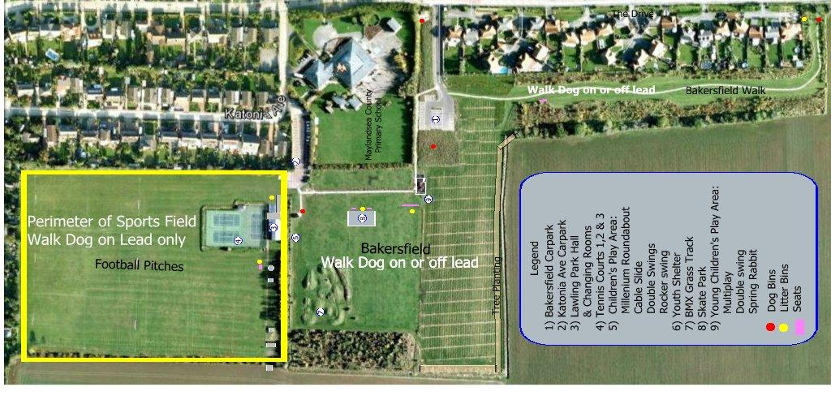

Cllr Peter Spires
Chair Lawling Park Committee
Mayland Parish Council
December 2018

